**Chapter 2 Multi-arm Bandits**

2.2 Action-Value Methods

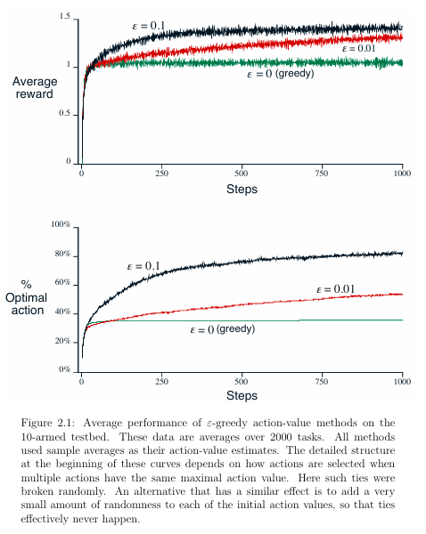

2.3 Incremental Implementation (Tracking a Stationary Problem)

Given this average and a kth reward for the action, Rk, then the average of all k rewards can be computed by:

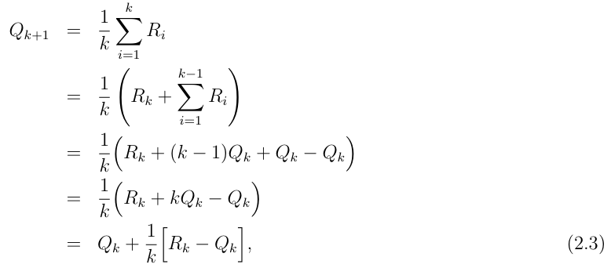

which holds even for k = 1, obtaining Q2 = R1 for arbitrary Q1. This imple mentation requires memory only for Qk and k, and only the small computation (2.3) for each new reward.

The update rule (2.3) is of a form that occurs frequently throughout this book. The general form is:



We sometimes use the informal shorthand = 1 k to refer to this case, leaving the dependence of k on the action implicit.

2.4 Tracking a Nonstationary Problem

the incremental update rule (2.3) for updating an average Qk of the k 1 past rewards is modified to be:



where the step-size parameter is constant. This results in Qk+1 being a weighted average of past rewards and the initial estimate Q1:

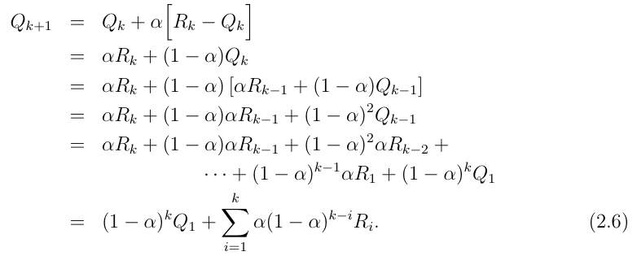

2.5 Optimistic Initial Values

